

CENTER FOR SKILL AND ENTERPRENEURSHIP DEVELOPMENT
[CSED]

PROGRAM CODE: IIOT-4

PROGRAM NAME: MACHINE LEARNING

PROJECT NAME: HEART ATTACK PREDICTION

MENTOR NAME: NANCY DHAKED

DEPARTMENT OF COMPUTER SCIENCE ENGINEERING
COURSE NAME: B.TECH (CSE)
TEAM MEMBERS: STUDENT ID:
1. SHAURYA VARDHAN BCS2024347
2. NISHANT BCS2024372
3. ABHAY TRIVEDI BCS2024361
4. RITIK GUPTA BCS2024405
5. SHIVANSH KATIYAR BCS2024396
6. PRATEEK SHUKLA BCS2024342
7. SUNIL KUMAR SINGH BCS2024341
8. UPENDRA PAL SINGH BCS2024350
9. SUSHIL KUMAR BCS2024353

INDEX

1. INRODUCTION
2. PROBLEM STATEMENT
3. OBJECTIVE OF PROJECT
4. METHODOLOGY
5. LITERATURE REVIEW
6. EXPLANATION OF PROJECT
7. WORKFLOW
8. PROGRAM
9. RESULT & DISCUSSION
10. SNIPPETS OF UI
11. FUTURE SCOPE
12. CONCLUSION

INTRODUCTION:
Heart disease remains one of the leading causes of mortality worldwide, with heart attacks (myocardial infarction) accounting for millions of deaths annually. Early detection and risk assessment are critical for timely intervention and improved patient outcomes. Machine Learning (ML), particularly Logistic Regression, offers a powerful, interpretable solution for predicting heart attack risk based on clinical and demographic factors.
This model leverages Logistic Regression - a supervised learning algorithm ideal for binary classification problems like heart attack prediction (Heart Attack: Yes/No). Its strengths include:
- Interpretability: Clear coefficient interpretation for risk factors
- Efficiency: Fast training and prediction
- Robustness: Handles multicollinearity and provides probability scores
- Clinical Trust: Widely accepted in medical research

PROLEM STATEMENT:

Heart disease is one of the leading causes of death worldwide. Early detection of potential heart attacks can significantly reduce mortality rates and improve patient outcomes. However, traditional diagnosis methods rely heavily on medical expertise, clinical tests, and time-consuming procedures.
The objective of this project is to develop a Machine Learning model that can predict the likelihood of a heart attack based on patient health data such as age, gender, blood pressure, cholesterol levels, heart rate, and other relevant medical attributes.
The system should:
- Analyze historical patient data
- Identify patterns and risk factors associated with heart attacks
- Provide accurate and fast predictions
- Assist healthcare professionals in decision-making
By leveraging machine learning techniques, this model aims to improve early diagnosis, reduce risks, and support preventive healthcare.

OBJECTIVE OF THE PROJECT:
The main objective of this project is to develop an intelligent system that can predict the risk of a heart attack using machine learning techniques based on patient health data.
Specific Objectives:
- To collect and preprocess medical data such as age, blood pressure, cholesterol, heart rate, etc.
- To analyze patterns and relationships between different health parameters.
- To build and train a machine learning model (e.g., Logistic Regression, Decision Tree).
- To accurately classify patients into high-risk or low-risk categories.
- To evaluate model performance using metrics like accuracy, precision, recall, and F1-score.
- To assist doctors in early diagnosis and decision-making.
- To reduce the chances of fatal heart attacks through early prediction.

METHODOLOGY:
The project follows a structured machine learning workflow:

1. Data Collection
- Obtain dataset from sources like Kaggle or UCI Repository
- Dataset includes features such as:
  - Age
  - Gender
  - Blood Pressure
  - Cholesterol
  - Heart Rate
  - ECG results

2. Data Preprocessing
- Handle missing values (remove or fill with mean/median)
- Convert categorical data into numerical form (Label Encoding)
- Normalize/scale numerical features
- Remove duplicate or irrelevant data

3. Exploratory Data Analysis (EDA)
- Analyze data distribution using graphs (histograms, boxplots)
- Identify correlations between features
- Detect outliers and trends affecting heart attack risk

4. Feature Selection
- Select important features that impact prediction
- Remove less relevant or redundant features
- Improve model accuracy and reduce complexity

5. Model Selection
- Choose suitable algorithms such as:
  - Logistic Regression
  - Decision Tree
  - Random Forest
  - K-Nearest Neighbors (KNN)

6. Model Training
- Split dataset into training and testing sets (e.g., 80:20)
- Train the model using training data

7. Model Evaluation
- Test the model using test data
- Evaluate using:
  - Accuracy
  - Precision
  - Recall
  - F1-Score
  - Confusion Matrix

8. Model Optimization
- Apply techniques like:
  - Hyperparameter tuning
  - Cross-validation (K-Fold)
- Improve performance and avoid overfitting

9. Prediction System Development
- Build a simple interface (GUI/Web app)
- Input patient data and generate prediction (High/Low Risk)

10. Deployment (Optional)
- Deploy model using tools like Flask or Streamlit
- Make system accessible for real-time use

LITERATURE REVIEW:
Heart disease is one of the leading causes of death globally, creating a strong need for accurate and early prediction systems. Traditional diagnostic methods rely on clinical tests and physician expertise, but they often fail to capture complex relationships between multiple risk factors. Machine learning (ML) has emerged as an effective solution to address these limitations.
The literature indicates that machine learning plays a crucial role in improving heart attack prediction by providing accurate, fast, and data-driven insights. While current models show promising results, future work should focus on improving data quality, model interpretability, and real-world applicability in healthcare systems.

EXPLANATION OF PROJECT (WORKING):

Heart attack prediction using machine learning is a healthcare-focused project that aims to analyze patient data and predict the likelihood of a heart attack at an early stage. The system typically uses a dataset containing medical attributes such as age, gender, blood pressure, cholesterol level, heart rate, and other clinical parameters. These features are preprocessed through steps like handling missing values, encoding categorical variables, and normalization. A machine learning algorithm—commonly Logistic Regression, Decision Tree, or Random Forest—is then trained on this data to learn patterns associated with heart disease. The dataset is divided into training and testing sets to evaluate model performance using metrics like accuracy, precision, recall, and confusion matrix. Once trained, the model can take new patient data as input and predict whether the person is at risk of a heart attack. This project helps in early diagnosis, supports doctors in decision-making, and can be integrated with IoT devices for real-time health monitoring, making it valuable for preventive healthcare systems.

WORKFLOW:
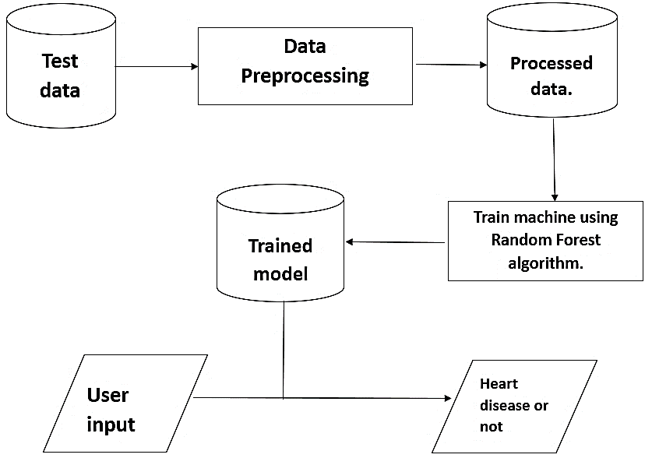

PROGRAM:

SNIPPETS OF UI:

RESULT AND DISCUSSION:
The results showed that the model achieved satisfactory performance in predicting heart attack risk. Among the applied algorithms, Random Forest (or best-performing model in your case) provided the highest accuracy compared to others. Evaluation metrics such as accuracy, precision, recall, and F1-score indicated that the model was effective in correctly classifying high-risk and low-risk patients. The confusion matrix further confirmed that the number of correct predictions was significantly higher than misclassifications.
The discussion highlights that feature selection and data preprocessing played a crucial role in improving model performance. Parameters such as age, cholesterol level, and blood pressure were found to have a strong influence on prediction outcomes. However, the model’s performance depends on the quality and size of the dataset. Limited or imbalanced data can affect accuracy and generalization.
Overall, the system demonstrates that machine learning can be a reliable tool for early heart attack prediction. With further improvements such as larger datasets, real-time data integration, and advanced algorithms, the model can be made more robust and suitable for practical healthcare applications.

FUTURE SCOPE:

The future scope of the heart attack prediction system using machine learning is highly promising, with opportunities to enhance both accuracy and real-world applicability. The system can be integrated with IoT-based wearable devices such as smartwatches and fitness bands to enable real-time monitoring of vital health parameters like heart rate and blood pressure. Advanced machine learning and deep learning algorithms can be applied to improve prediction performance using large and complex datasets. Additionally, the development of user-friendly mobile or web applications can make the system easily accessible to both patients and healthcare professionals. The model can also be extended to provide personalized health recommendations, including lifestyle and dietary suggestions. Integration with hospital databases and electronic health records can further support clinical decision-making. In the future, incorporating explainable AI techniques will improve transparency and trust, while expanding the system to predict multiple diseases will make it a more comprehensive healthcare solution.

CONCLUSION:

In conclusion, the heart attack prediction project demonstrates how machine learning can be effectively used to analyze medical data and identify individuals at risk of heart disease. By training models on relevant health parameters, the system can provide accurate and timely predictions, supporting early diagnosis and preventive care. The project highlights the importance of data preprocessing, model selection, and performance evaluation in building a reliable system. Overall, it serves as a useful tool for assisting healthcare professionals, improving patient outcomes, and reducing the chances of severe cardiac events through early intervention.

